

|  |
| --- |
| Close-up image showing the leaf-sides of two oversized books side-by-side on a bookshelf, with additional books in soft focus background |
| Equitable Services Informational Packet  (Updated May 2022) |
|  |

Contents

Introduction and Welcome 4

Timely and Meaningful Consultation 5

Goal of Consultation 6

Consultation Topics for Services Worksheet 6

Equitable Services Affirmation 7

Complaint Process for Private School Officials 9

Summary of Programs 10

Title I, Part A, Improving the Academic Achievement of the Disadvantaged 10

Title II, Part A 10

Title III, Part A, Language Instruction for English Learner (EL) Students 10

Title IV Part A, Student Support and Academic Enrichment (SSAE) Program 11

Authorized Use of Funds 11

Title I, Part A Authorized Use of Funds 11

Title II, Part A Authorized Use of Funds 12

Title IV, Authorized Use of Funds 14

Allowable Expenditures 16

Allowable Title I Program Expenditures 16

Allowable Title I Expenditures for Service Providers 16

Location of Title I Services and Equipment 16

Allowable Title II Program Expenditures 17

Allowable Title IV Program Expenditures 17

Well-Rounded Education Activities 17

Safe and Healthy Student Activities 18

Effective Use of Technology Activities 20

Obligation of Funds 22

Allocation of Funds 22

Control of Public Funds 23

Initial Distribution 23

Collection 23

Redistribution 23

Procurement Procedures 24

Purchasing Process 24

**Elements of a Public Bid** 24

**Procurement Procedures General Information** 25

**Methods of Procurement** 25

**Micropurchase Method – $10,000 or less (2 CFR, Section 200.320[a])** 25

**Small Purchase Method – purchases less than $250,000 (2 CFR, Section 200.320[b])** 26

Professional Development Process 27

Conference Attendance Request (CAR) 27

Equitable Services Allocation Calculation 28

Methodology 28

Title I, Part A – Equitable Services Proportional Share Formula and Methodology 28

Title II, Equitable Services Proportional Share Formula and Methodology 29

Title IV, Equitable Services Proportional Share Formula and Methodology 30

Title I Parent Meeting 31

Home Language Survey 32

Federal Program Monitoring 33

Equitable Services Plan Development 34

Funding Allocation Profile 34

Purpose and Description 34

Private School Demographics 34

Stakeholder Involvement 34

Comprehensive Needs Assessment Summary 34

School Goals 34

Measureable Outcomes 35

Actions/Services 35

Proposed Expenditures 35

Annual Review/Evaluation 35

Budget Summary 35

Timeline for Equitable Services 37

# Introduction and Welcome

Dear Principal and/or Designee,

Stockton Unified School District is pleased to work with your private nonprofit school to ensure students who are eligible for Title I, II, III, and/or IV services are academically successful.

In February 2022, Stockton Unified sent out a letter inquiring of participation of private nonprofit schools for 2022-23 School Year. As a result, you have responded with interest to participate in Title I, II, III, and/or IV programs operated by the district.

The equitable services offered because of ESSA requirements are to eligible students, their families, teachers, and other educational personnel. The educational services and other benefits provided for nonprofit private school children, teachers, and other educational personnel must be equitable in comparison to services and other benefits for public children, teachers, and other educational personnel participating in the program, and provided in a timely manner.

Although services are to be allowable and comparable to those provided to public school students and teachers participating in the program, it is understandable that services can be different from the services provided to public school participants. Services need to be secular, neutral, and non-ideological. In addition, the services provided based on need(s) identified through a needs assessment and evaluated annually. Most importantly, equitable services funding cannot be directly distributed to the private school.

The purpose of this document is to provide information on equitable services and Stockton Unified School District’s policies and practices upholding the requirements for equitable services.

The district has created an Equitable Services for Non-Profit Private Schools webpage (<https://www.stocktonusd.net/Page/13592>) to provide all documentation pertaining to nonprofit private school as a central resource. This packet along with the fillable PDF documents for the Conference Attendance Request (CAR) and the Equitable Services Plan are available for access anytime.

Thank you and we look forward to a successful year!

Tiffany Ashworth

Coordinator, State and Federal

# Timely and Meaningful Consultation

Sections 1117(b) and 8501(c) of Every Student Succeeds Act (ESSA) require that timely and meaningful consultation occur between the local educational agency (LEA) and private school officials prior to any decision that affects the opportunities of eligible private school children, their teachers, families, and other educational personnel to participate in programs subject to equitable participation, and shall continue throughout the implementation and assessment of activities.

Consultation for all programs must be conducted before the LEA has made any decisions that will impact the participation of private school students and teachers in applicable programs and shall continue throughout implementation and assessment of services provided. Additionally, with respect to Title I, Part A programs, consultation must also be conducted during the design and development of the LEA’s Title I, Part A programs.

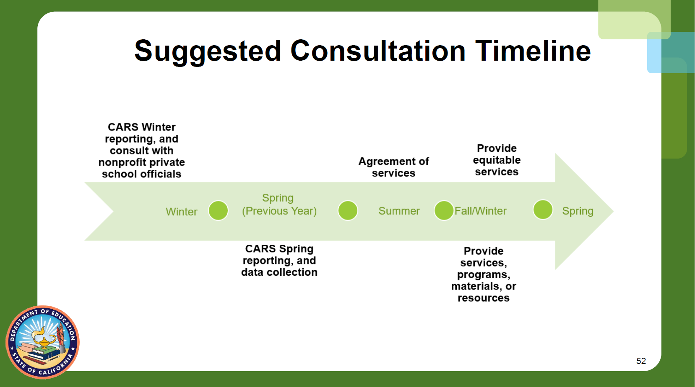

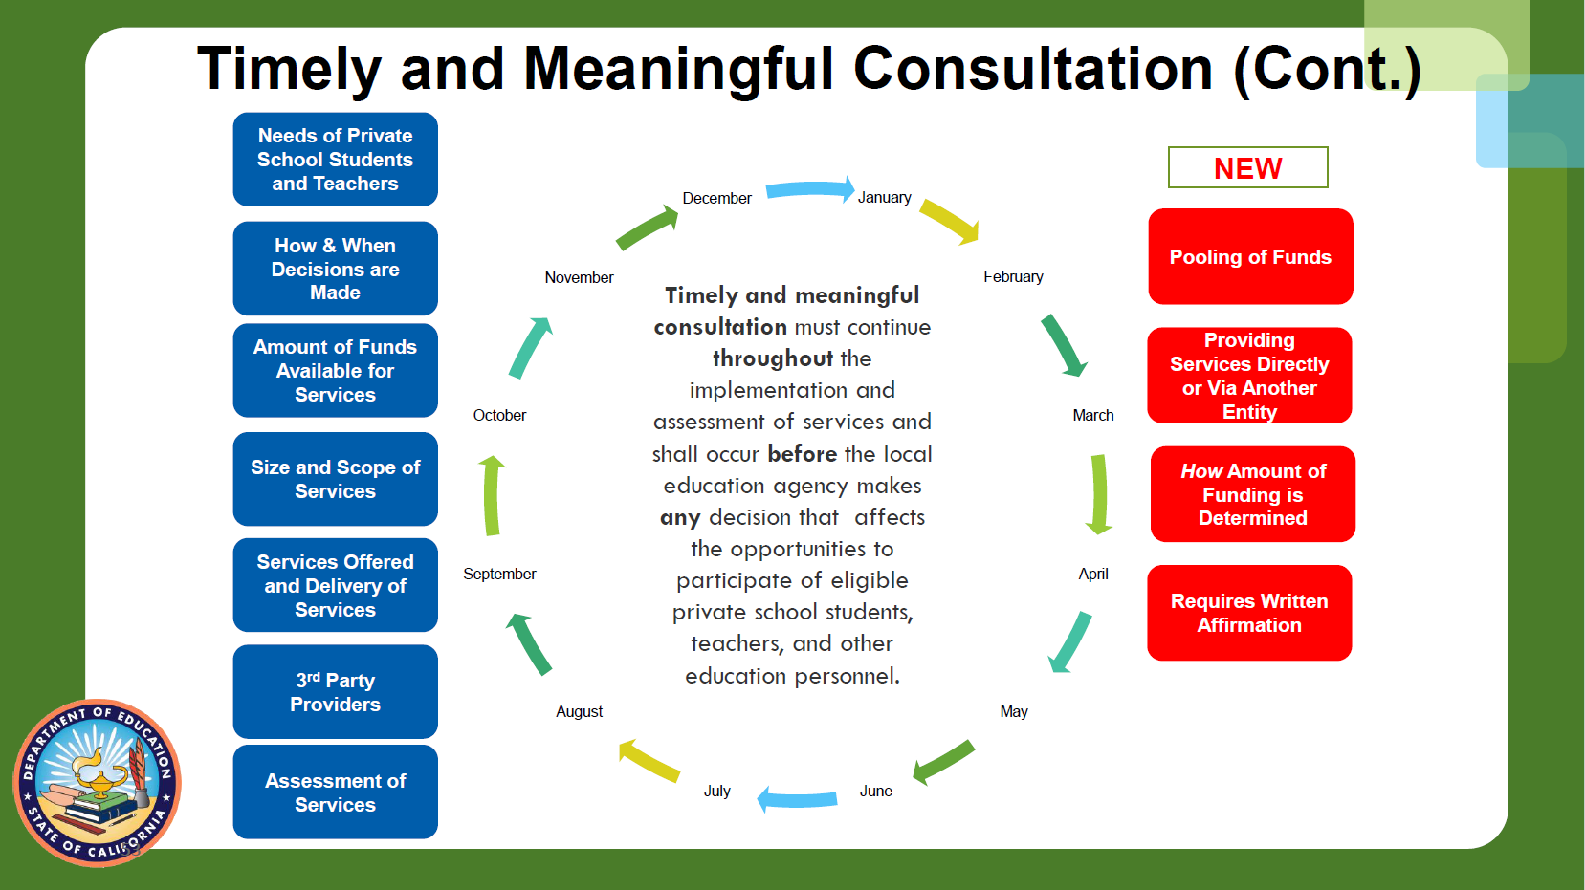

# Goal of Consultation

Sections 1117(b)(1) and 8501(c) of ESSA state that the goal of consultation is agreement between the LEA and appropriate private school officials on how to provide equitable and effective programs for eligible private school children. The “goal of reaching agreement” between an LEA and appropriate private school officials is grounded in timely, meaningful, and open communication between the LEA and the private school officials on key issues that are relevant to the equitable participation of eligible private school students, teachers and other education personnel, and families in ESSA programs.

## Consultation Topics for Services Worksheet

This list of consultation topics provides the LEA officials with the specific topics that must be covered in consultation meetings as required under 20 U.S.C. 8501[c].

As LEA and private school officials address and complete discussions on each topic, the LEA officials may want to check-off each item as finished so to create a record for future reference should the need arise. (A fillable PDF version is available online at <https://www.stocktonusd.net/Page/13592>)

Consultation Topics Include:

* How the children’s needs will be identified (20 U.S.C. 8501[c][1][A])
* What services will be offered. (20 U.S.C 8501[c][1][B])
* How, where and by whom the services will be provided, including services by a third party provider. (20 U.S.C. 8501[c][1][C])
* How the services will be academically assessed and how the results of the assessment will be used to improve those services. (20 U.S.C. 8501[c][1][D])
* The size and scope of the equitable services to be provided to the eligible private school children, the proportion of funds allocated and how that proportion of funds is determined. (20 U.S.C. 8501[b][1][E])
* The method and sources of data that are used to determine the number of children from low income families in participating school attendance areas who attend private schools. (20 U.S.C. 8501[b][1][F])
* How and when decisions will be made regarding the delivery of services to private school children. (20 U.S.C. 8501[b][1][G])
* How the LEA will provide in writing to the private school officials an analysis of the reasons for not using a contractor preferred by private school officials. (20 U.S.C. 8501[b][1][H])
* Whether the LEA shall provide services directly or through a separate government agency, consortium, entity, or third party contractor. (20 U.S.C. 8501[b][1][I])
* If the LEA will create a pool or pools of funds to provide the equitable services to eligible private school students. (20 U.S.C. 8501[b][1][J])
* When, including the approximate time of the day, the services will be provided. (20 U.S.C. 8501[b][1][K])
* Whether to consolidate and use funds provided under applicable programs under ESEA 8501 to provide services to eligible private school students participating in programs. (20 U.S.C. 8501[b][1][L])

## Equitable Services Affirmation

Throughout the consultation process, nonprofit private schools will be required to complete an affirmation to express the belief of the nonprofit private school regarding equitable services consultation. The following is an excerpt from the district’s affirmation document:

For participating private schools, the LEA and private school officials shall both have the goal of reaching agreement on how to provide equitable and effective programs for eligible private school students. The consultation process shall include consultation on issues relating to the programs. Section 9501(c)(1) of *ESEA*

If Stockton Unified School District (the agency, consortium or entity) disagrees with the views of the private school officials on the provision of services through a contract, SUSD (the agency, consortium or entity) shall provide to the private schools a written explanation of the reasons by the LEA has not chosen to use a contractor.

The private school official shall have the right to file a complaint with the State that the consultation was not meaningful and timely and did not give due consideration to the views of the private school official or did not make a decision that treats the private school it its students equitably.

Please check **one** box indicating your belief regarding equitable services consultation.

Timely and meaningful consultation has occurred

Timely and meaningful consultation did not occur

Program design is not equitable with respect to eligible private school children

Timely and meaningful consultation did not occur and the program design is not equitable with respect to eligible private school children. (do you need this one too?)

# Complaint Process for Private School Officials

The California Department of Education Equitable Services Ombudsman is available to provide support and guidance on matters pertaining to equitable services.

Prior to reaching out to the Equitable Services Ombudsman, the district will provide every effort possible to resolve complaints at the lowest level practicable.

Complaints/concerns should be addressed to the Coordinator supporting State and Federal and Equitable Services for review, discussion and resolution.

If resolution is not to the satisfaction of either party, the complaint/concern may be escalated to the Director, Educational Services or designee overseeing State and Federal. Individuals involved will be able to present the complaint/concern for review and resolution.

If resolution continues to not meet the satisfaction of the non-profit private school, the private school official has the right file a complaint with the district through the district’s uniform complaint process (UCP) or they can file a complaint directly with the SEA through the state UPC office.

Private school officials have the right to file a complaint with the California Department of Education if the district:

* did not engage in consultation that was meaningful and timely;
* did not give due consideration to the views of the private school official;
* did not make a decision that treats the private school students equitably; or
* was found noncompliant with the requirements of the ESSA regarding the equitable services to children, staff, and families of the children participating in private schools (ESSA sections 1117[b][6][A] and 8501[c][6][A]).

The district’s Constituent Services oversees the uniform complaint process, which is available on the district’s website at: <https://www.stocktonusd.net/Page/7498>.

The California Department of Education’s Equitable Services Ombudsman contact information is:

Sylvia Hanna, Education Programs Consultant

[shanna@cde.ca.gov](mailto:shanna@cde.ca.gov)

Phone: 916-319-0948

# Summary of Programs

## Title I, Part A, Improving the Academic Achievement of the Disadvantaged

Title I, Part A provides supplemental educational services to disadvantaged students in high-poverty public school attendance areas. Funds are allocated based on the number of students whose families receive free or reduced lunch or meet acceptable poverty identification methods. At this time, funding amounts are uncertain.

If the private school is a sectarian school, the instruction may not be delivered directly by the private school staff.

To be eligible, a student must meet all three criteria:

1. be in grades Kindergarten through 12 (2020-21 school year) and not older than age 21,
2. reside in an eligible elementary or high school attendance area of Stockton Unified School District and must be enrolled in any nonprofit private or secondary school, and
3. be identified through District teacher assessment criteria as a low achieving student in reading and/or math.

In addition, students included maybe economically disadvantaged, students with disabilities, migrant students or English learners (ELs).

## Title II, Part A

Title II, Part A, focuses on upgrading the expertise of teachers, paraprofessionals, or other instructional personnel to enable them to teach all children in the core academic subjects; and supports sustained and intensive, high quality professional development directed to achieving high performance standards related to challenging State content standards.

Eligibility is based on the number of students who are enrolled in nonprofit private elementary and secondary schools in the geographical areas served by the district.

## Title III, Part A, Language Instruction for English Learner (EL) Students

Title III, part A, authorizes funding for supplementary programs and services for EL students. Required activities include the provision of instruction and instructional support services related to English language development and academic progress in the core curriculum in a manner that allows EL students to meet grade level and graduation requirements. Programs also must provide staff development opportunities to school staff assigned to EL student populations. Title III funds may also be used for as variety of instructional support, curricular development, parent involvement and related EL student program activities.

## Title IV Part A, Student Support and Academic Enrichment (SSAE) Program

Title IV Part A authorizes funding for activities to provide all students with access to a well-rounded education, improve school conditions to support safe and healthy students and to support effective use of technology in order to improve the academic achievement and digital literacy of all students.

# Authorized Use of Funds

## Title I, Part A Authorized Use of Funds

The California Department of Education (CDE) recommends that local educational agencies (LEAs), County Offices of Education, and direct funded charter schools consider the following general criteria when approving activities or expenditures supported with Title I, Part A funds:

1. The activity/expenditure is aligned to meet the challenging State academic content standards (Every Student Succeeds Act [ESSA] sections 1112[a][3][B][i] and 1112[b]);
2. The activity/expenditure is an evidenced-based educational strategy (ESSA sections 1003[b][1][B]; 1114[d]; and 1115[h]);
3. The activity/expenditure is reasonable, necessary, and allocable cost to the program (2 *CFR* 200.404 - 200.405);
4. Title I, Part A funds used supplement the funds that would, in the absence of such funds, be made available from State and local sources, and do not supplant such funds (ESSA Section 1118[b][1]);
5. Title I, Part A funds used are current Federal fiscal year or the subsequent fiscal year (ESSA Section 1127[a]).

Title I Schoolwide Programs (SWP) should consider the following general criteria when approving activities or expenditures supported with Title I, Part A funds:

1. The activity/expenditure meets a need identified in the comprehensive needs assessment (ESSA Section 1114[b][6]);
2. The activity/expenditure is included in the Single Plan for Student Achievement (SPSA) (*Education Code* [*EC*] Section 64001[g][C][3]);
3. The SPSA has been approved by the local governing board (*EC* Section 64001[i]);
4. The Schoolsite Council (SSC) annually evaluates and monitors the implementation of the SPSA and progress towards accomplishing the goals (*EC* Section 64001[g][2][B] and [i]); and
5. The activity/expenditure has been reviewed, approved, and recommended by the SSC to the local governing board (*EC* Section 64001[d]).

Title I Targeted Assistance Schools (TAS) should consider the following general criteria when approving activities or expenditures supported with Title I, Part A funds:

1. The activity/expenditure serves the needs of students that are identified as failing, or most at risk of failing to meet challenging State academic standards on the basis of multiple, educational related, objective criteria established by the LEA and supplemented by the school (ESSA Section 1115[c][1][B]);
2. The activity/expenditure is included on an ongoing basis, review of the progress of eligible children and revise the TAS program, if necessary, to provide additional assistance, to enable such children to meet the challenging State academic standards (ESSA Section 1115[b][G][iii]).

If an expenditure/activity does not meet all of the above rationale, it is not likely to be an authorized use of Title I, Part A funds.

## Title II, Part A Authorized Use of Funds

* Funds are used to provide supplemental professional development services for eligible nonprofit private school staff.
* Professional development activities must be based on needs assessment.
* Professional development activities must be approved by the LEA.
* Professional development activities are for the benefit of individual staff and not for the benefit of the nonprofit private school.
* All funds must remain in control of the LEA responsible for providing equitable services.

§6613. Local uses of funds

(a) In general - A local educational agency that receives a subgrant under section 6612 of this title shall use the funds made available through the subgrant to develop, implement, and evaluate comprehensive programs and activities described in subsection (b), which may be carried out-

(1) through a grant or contract with a for-profit or nonprofit entity; or

(2) in partnership with an institution of higher education or an Indian tribe or tribal organization (as such terms are defined under section 5304 of title 25).

(b) Types of activities - The programs and activities described in this subsection-

(1) shall be in accordance with the purpose of this subchapter;

(2) shall address the learning needs of all students, including children with disabilities, English learners, and gifted and talented students; and

(3) may include, among other programs and activities-

(A) developing or improving a rigorous, transparent, and fair evaluation and support system for teachers, principals, or other school leaders that-

(i) is based in part on evidence of student achievement, which may include student growth; and

(ii) shall include multiple measures of educator performance and provide clear, timely, and useful feedback to teachers, principals, or other school leaders;

(B) developing and implementing initiatives to assist in recruiting, hiring, and retaining effective teachers, particularly in low-income schools with high percentages of ineffective teachers and high percentages of students who do not meet the challenging State academic standards, to improve within-district equity in the distribution of teachers, consistent with section 6311(g)(1)(B) of this title, such as initiatives that provide-

(i) expert help in screening candidates and enabling early hiring;

(ii) differential and incentive pay for teachers, principals, or other school leaders in high-need academic subject areas and specialty areas, which may include performance-based pay systems;

(iii) teacher, paraprofessional, principal, or other school leader advancement and professional growth, and an emphasis on leadership opportunities, multiple career paths, and pay differentiation;

(iv) new teacher, principal, or other school leader induction and mentoring programs that are designed to-

(I) improve classroom instruction and student learning and achievement; and

(II) increase the retention of effective teachers, principals, or other school leaders;

(v) the development and provision of training for school leaders, coaches, mentors, and evaluators on how accurately to differentiate performance, provide useful feedback, and use evaluation results to inform decision-making about professional development, improvement strategies, and personnel decisions; and

(vi) a system for auditing the quality of evaluation and support systems;

(C) recruiting qualified individuals from other fields to become teachers, principals, or other school leaders, including mid-career professionals from other occupations, former military personnel, and recent graduates of institutions of higher education with records of academic distinction who demonstrate potential to become effective teachers, principals, or other school leaders;

(D) reducing class size to a level that is evidence-based, to the extent the State (in consultation with local educational agencies in the State) determines that such evidence is reasonably available, to improve student achievement through the recruiting and hiring of additional effective teachers;

(E) providing high-quality, personalized professional development that is evidence-based, to the extent the State (in consultation with local educational agencies in the State) determines that such evidence is reasonably available, for teachers, instructional leadership teams, principals, or other school leaders, that is focused on improving teaching and student learning and achievement, including supporting efforts to train teachers, principals, or other school leaders to-

(i) effectively integrate technology into curricula and instruction (including education about the harms of copyright piracy);

(ii) use data to improve student achievement and understand how to ensure individual student privacy is protected, as required under section 1232g of this title (commonly known as the "Family Educational Rights and Privacy Act of 1974") and State and local policies and laws in the use of such data;

(iii) effectively engage parents, families, and community partners, and coordinate services between school and community;

(iv) help all students develop the skills essential for learning readiness and academic success;

(v) develop policy with school, local educational agency, community, or State leaders; and

(vi) participate in opportunities for experiential learning through observation;

(F) developing programs and activities that increase the ability of teachers to effectively teach children with disabilities, including children with significant cognitive disabilities, and English learners, which may include the use of multi-tier systems of support and positive behavioral intervention and supports, so that such children with disabilities and English learners can meet the challenging State academic standards;

(G) providing programs and activities to increase-

(i) the knowledge base of teachers, principals, or other school leaders on instruction in the early grades and on strategies to measure whether young children are progressing; and

(ii) the ability of principals or other school leaders to support teachers, teacher leaders, early childhood educators, and other professionals to meet the needs of students through age 8, which may include providing joint professional learning and planning activities for school staff and educators in preschool programs that address the transition to elementary school;

(H) providing training, technical assistance, and capacity-building in local educational agencies to assist teachers, principals, or other school leaders with selecting and implementing formative assessments, designing classroom-based assessments, and using data from such assessments to improve instruction and student academic achievement, which may include providing additional time for teachers to review student data and respond, as appropriate;

(I) carrying out in-service training for school personnel in-

(i) the techniques and supports needed to help educators understand when and how to refer students affected by trauma, and children with, or at risk of, mental illness;

(ii) the use of referral mechanisms that effectively link such children to appropriate treatment and intervention services in the school and in the community, where appropriate;

(iii) forming partnerships between school-based mental health programs and public or private mental health organizations; and

(iv) addressing issues related to school conditions for student learning, such as safety, peer interaction, drug and alcohol abuse, and chronic absenteeism;

(J) providing training to support the identification of students who are gifted and talented, including high-ability students who have not been formally identified for gifted education services, and implementing instructional practices that support the education of such students, such as-

(i) early entrance to kindergarten;

(ii) enrichment, acceleration, and curriculum compacting activities; and

(iii) dual or concurrent enrollment programs in secondary school and postsecondary education;

(K) supporting the instructional services provided by effective school library programs;

(L) providing training for all school personnel, including teachers, principals, other school leaders, specialized instructional support personnel, and paraprofessionals, regarding how to prevent and recognize child sexual abuse;

(M) developing and providing professional development and other comprehensive systems of support for teachers, principals, or other school leaders to promote high-quality instruction and instructional leadership in science, technology, engineering, and mathematics subjects, including computer science;

(N) developing feedback mechanisms to improve school working conditions, including through periodically and publicly reporting results of educator support and working conditions feedback;

(O) providing high-quality professional development for teachers, principals, or other school leaders on effective strategies to integrate rigorous academic content, career and technical education, and work-based learning (if appropriate), which may include providing common planning time, to help prepare students for postsecondary education and the workforce; and

(P) carrying out other activities that are evidence-based, to the extent the State (in consultation with local educational agencies in the State) determines that such evidence is reasonably available, and identified by the local educational agency that meet the purpose of this subchapter.

Pub. L. 89–10, title II, §2103, as added Pub. L. 114–95, title II, §2002, Dec. 10, 2015, 129 Stat. 1926.

## Title IV, Authorized Use of Funds

The California Department of Education (CDE) recommends that local educational agencies (LEAs) consider the following general criteria when approving activities or expenditures supported with Title IV, Part A funds:

1. The activity/expenditure is aligned to meet the purpose to improve students’ academic achievement (Every Student Succeeds Act [ESSA] Section 4101);
2. The activity/expenditure is reasonable, necessary, and allocable cost to the program (2 Code of Federal Regulations 200.404 - 200.405);
3. Title IV, Part A funds used supplement the funds that would, in the absence of such funds, be made available from State and local sources, and do not supplant such funds (ESSA Section 4110);
4. Title IV, Part A funds used are current Federal fiscal year or the subsequent fiscal year (General Education Provisions Act Section 420);
5. The activity/expenditure meets a need identified in the comprehensive needs assessment (ESSA Section 4106[d][1]);
6. The activity/expenditure to support safe and healthy students is an evidenced-based educational strategy (ESSA Section 4108).

If an expenditure/activity does not meet the above rationale, it is not likely to be an authorized use of Title IV, Part A funds.

# Allowable Expenditures

## Allowable Title I Program Expenditures

Title I funds are expended to implement academic evidence-based programs that help students improve their academic achievement in the regular private school classrooms (i.e., reading, mathematics, etc.). Title I program expenditures can include the following:

1. Books, materials, and equipment necessary to implement the Title I program (The LEA retains title to the books, other materials, and equipment purchased with Title I funds. Materials, etc. purchased with Title I funds may be used only by Title I participants. Each item purchased with Title I funds must be labeled “Property of Stockton Unified School District.” The labels should not be either easily erased or removable.);
2. Extended-day services;
3. Summer programs;
4. Saturday programs;
5. Counseling programs;
6. Computer-assisted instruction (CAI) with non-instructional computer technicians who supervise computer labs, maintain discipline, and escort students to and from class (Their salaries are an administrative cost under Sec 200.77(f) of the Title I regulations and may not be charged to funds generated by private school children from low-income families, which is for instruction.);
7. Home tutoring;
8. Computers and software products; and
9. Take-home computers (The LEA should ensure that families and students are properly trained in computer and software use.).

## Allowable Title I Expenditures for Service Providers

These expenditures include:

1. Salaries and fringe benefits for highly qualified teachers directly hired by the LEA;
2. Salaries and fringe benefits for qualified paraprofessionals directly hired by the LEA and supervised by highly qualified public school teachers who are located in the same building;
3. LEA contracts with third-party providers. (The contract should provide information that ensures the LEA that the Title I program contract will be administered in accordance with all requirements. The LEA must exercise oversight of the instructional program and administrative costs); and
4. LEA contracts with retired public or private school teachers to teach at the private school during the school day and before or after school.

## Location of Title I Services and Equipment

1. Title I services must be provided in a separate space that is under the LEA’s control when Title I services are being provided;
2. If the services are provided in a library or private school classroom, the space must be separate and partitioned off; and
3. Computer equipment and other supplies purchased with Title I funds may be used only by Title I students in the Title I program.

## Allowable Title II Program Expenditures

* Content specific professional development
* Instructional Teaching Strategies
* Classroom Management/Improving Student Behavior
* Working with Students with Different Needs/Differentiation Strategies
* Instructional Leadership
* Integrating Technology into the Curriculum/Data Analysis

## Allowable Title IV Program Expenditures

### Well-Rounded Education Activities

Each LEA, or consortium of such agencies, that receives a Title IV, Part A allocation pursuant to ESSA Section 4107 shall use a portion of such funds to develop and implement programs and activities that support access to a well-rounded education and that—

1. are coordinated with other schools and community based services and programs;
2. may be conducted in partnership with an institution of higher education, business, nonprofit organization, community based organization, or other public or private entity with a demonstrated record of success in implementing activities; and
3. may include programs and activities, such as—
   1. college and career guidance and counseling programs, such as—
      1. postsecondary education and career awareness and exploration activities; information in assisting students with postsecondary education and career planning; and
      2. financial literacy and Federal financial aid awareness activities;
   2. programs and activities that use music and the arts as tools to support student success through the promotion of constructive student engagement, problem solving, and conflict resolution;
   3. programming and activities to improve instruction and student engagement in science, technology, engineering, and mathematics, including computer science, (referred to in this section as ‘‘STEM subjects’’) such as—
      1. increasing access for students through grade 12 who are members of groups underrepresented in such subject fields, such as female students, minority students, English learners, children with disabilities, and economically disadvantaged students, to high-quality courses;
      2. supporting the participation of low-income students in nonprofit competitions related to STEM subjects (such as robotics, science research, invention, mathematics, computer science, and technology competitions);
      3. providing hands-on learning and exposure to science, technology, engineering, and mathematics and supporting the use of field-based or service learning to enhance the students’ understanding of the STEM subjects;
      4. supporting the creation and enhancement of STEM-focused specialty schools;
      5. facilitating collaboration among school, afterschool program, and informal program personnel to improve the integration of programming and instruction in the identified subjects; and
      6. integrating other academic subjects, including the arts, into STEM subject programs to increase participation in STEM subjects, improve attainment of skills related to STEM subjects, and promote well-rounded education;
   4. efforts to raise student academic achievement through accelerated learning programs, such as—
      1. reimbursing low-income students to cover part or all of the costs of accelerated learning examination fees, if the low-income students are enrolled in accelerated learning courses and plan to take accelerated learning examinations; or
      2. increasing the availability of, and enrollment in, accelerated learning courses, accelerated learning examinations, dual or concurrent enrollment programs, and early college high school courses;
   5. activities to promote the development, implementation, and strengthening of programs to teach traditional government education;
   6. foreign language instruction;
   7. environmental education;
   8. programs and activities that promote volunteerism and community involvement;
   9. programs and activities that support educational programs that integrate multiple disciplines, such as programs that combine arts and mathematics; or
   10. other activities and programs to support student access to, and success in, a variety of well-rounded education experiences.

### Safe and Healthy Student Activities

Each LEA, or consortium of such agencies, that receives a Title IV, Part A allocation pursuant to ESSA Section 4108 shall use a portion of such funds to develop, implement, and evaluate comprehensive programs and activities that—

1. are coordinated with other schools and community based services and programs;
2. foster safe, healthy, supportive, and drug-free environments that support student academic achievement;
3. promote the involvement of parents in the activity or program;
4. may be conducted in partnership with an institution of higher education, business, nonprofit organization, community based organization, or other public or private entity with a demonstrated record of success in implementing activities described in this section; and
5. may include, among other programs and activities—
   1. drug and violence prevention activities and programs that are evidence-based (to the extent the State, in consultation with LEAs in the state, determines that such evidence is reasonably available) including—
      1. programs to educate students against the use of alcohol, tobacco, marijuana, smokeless tobacco products, and electronic cigarettes; and
      2. professional development and training for school and specialized instructional support personnel and interested community members in prevention, education, early identification, intervention mentoring, recovery support services and, where appropriate, rehabilitation referral, as related to drug and violence prevention;
   2. in accordance with ESSA Section 4001 (General Provisions) and Section 4111 (Rule of Construction)—
      1. school-based mental health services, including early identification of mental health symptoms, drug use, and violence, and appropriate referrals to direct individual or group counseling services, which may be provided by school-based mental health services providers; and
      2. school-based mental health services partnership programs that—
         1. are conducted in partnership with a public or private mental health entity or health care entity; and
         2. provide comprehensive school-based mental health services and supports and staff development for school and community personnel working in the school that are—
            1. based on trauma-informed practices that are evidence-based (to the extent the State, in consultation with LEAs in the state, determines that such evidence is reasonably available);
            2. coordinated (where appropriate) with early intervening services provided under the Individuals with Disabilities Education Act (20 U.S.C. 1400 et seq.); and
            3. provided by qualified mental and behavioral health professionals who are certified or licensed by the State involved and practicing within their area of expertise;
   3. programs or activities that—
      1. integrate health and safety practices into school or athletic programs;
      2. support a healthy, active lifestyle, including nutritional education and regular, structured physical education activities and programs, that may address chronic disease management with instruction led by school nurses, nurse practitioners, or other appropriate specialists or professionals to help maintain the well-being of students;
      3. help prevent bullying and harassment;
      4. improve instructional practices for developing relationship-building skills, such as effective communication, and improve safety through the recognition and prevention of coercion, violence, or abuse, including teen and dating violence, stalking, domestic abuse, and sexual violence and harassment;
      5. provide mentoring and school counseling to all students, including children who are at risk of academic failure, dropping out of school, involvement in criminal or delinquent activities, or drug use and abuse;
      6. establish or improve school dropout and reentry programs; or
      7. establish learning environments and enhance students’ effective learning skills that are essential for school readiness and academic success, such as by providing integrated systems of student and family supports;
   4. high-quality training for school personnel, including specialized instructional support personnel, related to—
      1. suicide prevention;
      2. effective and trauma-informed practices in classroom management;
      3. crisis management and conflict resolution techniques;
      4. human trafficking (defined as an act or practice described in paragraph (9) or (10) of section 103 of the Trafficking Victims Protection Act of 2000 (22 U.S.C. 7102));
      5. school-based violence prevention strategies;
      6. drug abuse prevention, including educating children facing substance abuse at home; and
      7. bullying and harassment prevention;
   5. in accordance with ESSA Section 4001 (General Provisions) and Section 4111 (Rule of Construction), child sexual abuse awareness and prevention programs or activities, such as programs or activities designed to provide—
      1. age-appropriate and developmentally-appropriate instruction for students in child sexual abuse awareness and prevention, including how to recognize child sexual abuse and how to safely report child sexual abuse; and
      2. information to parents and guardians of students about child sexual abuse awareness and prevention, including how to recognize child sexual abuse and how to discuss child sexual abuse with a child;
   6. designing and implementing a locally-tailored plan to reduce exclusionary discipline practices in elementary and secondary schools that—
      1. is consistent with best practices;
      2. includes strategies that are evidence-based (to the extent the State, in consultation with LEAs in the state, determines that such evidence is reasonably available); and
      3. is aligned with the long-term goal of prison reduction through opportunities, mentoring, intervention, support, and other education services, referred to as a ‘‘youth PROMISE plan’’; or
   7. implementation of schoolwide positive behavioral interventions and supports, including through coordination with similar activities carried out under the Individuals with Disabilities Education Act (20 U.S.C. 1400 et seq.), in order to improve academic outcomes and school conditions for student learning;
   8. designating a site resource coordinator at a school or LEA to provide a variety of services, such as—
      1. establishing partnerships within the community to provide resources and support for schools;
      2. ensuring that all service and community partners are aligned with the academic expectations of a community school in order to improve student success; and
      3. strengthening relationships between schools and communities; or
         1. pay for success initiatives aligned with the purposes of this section.

### Effective Use of Technology Activities

Each LEA, or consortium of such agencies, that receives a Title IV, Part A allocation pursuant to ESSA Section 4109 shall use a portion of such funds to improve the use of technology to improve the academic achievement, academic growth, and digital literacy of all students, including by meeting the needs of such agency or consortium that are identified in the needs assessment conducted (if applicable), which may include—

1. providing educators, school leaders, and administrators with the professional learning tools, devices, content, and resources to—
   1. personalize learning to improve student academic achievement;
   2. discover, adapt, and share relevant high-quality educational resources;
   3. use technology effectively in the classroom, including by administering computer-based assessments and blended learning strategies; and
   4. implement and support school and district-wide approaches for using technology to inform instruction, support teacher collaboration, and personalize learning;
2. building technological capacity and infrastructure, which may include—
   1. procuring content and ensuring content quality; and
   2. purchasing devices, equipment, and software applications in order to address readiness shortfalls;
3. developing or using effective or innovative strategies for the delivery of specialized or rigorous academic courses and curricula through the use of technology, including digital learning technologies and assistive technology;
4. carrying out blended learning projects, which shall include—
   1. planning activities, which may include development of new instructional models (including blended learning technology software and platforms), the purchase of digital instructional resources, initial professional development activities, and one-time information technology purchases, except that such expenditures may not include expenditures related to significant construction or renovation of facilities; or
   2. ongoing professional development for teachers, principals, other school leaders, or other personnel involved in the project that is designed to support the implementation and academic success of the project;
5. providing professional development in the use of technology (which may be provided through partnerships with outside organizations) to enable teachers and instructional leaders to increase student achievement in the areas of science, technology, engineering, and mathematics, including computer science; and
6. providing students in rural, remote, and underserved areas with the resources to take advantage of high-quality digital learning experiences, digital resources, and access to online courses taught by effective educators.

An LEA, or consortium of such agencies, shall not use more than 15 percent of funds for purchasing technology infrastructure, which shall include technology infrastructure purchased for the activities pursuant to ESSA Section 4109[a][4][A].

# Obligation of Funds

Funds allocated to an LEA for educational services and other benefits to eligible private school children, teachers, and other educational personnel, and families must be obligated in the fiscal year for which the funds are received by the LEA. (ESEA section 8501[a][4][B]

SUSD obligates funds to eligible private schools based on a proportional share and methodology, which is provided and updated as applicable. Updates may be required due to changes in the district’s actual Title I, II, III, and/or IV awarded funds.

## Allocation of Funds

SUSD staff and the private school representative will work together to ensure allocations of obligated funds are distributed within the Equitable Services Plan to support actions/services for eligible children, teachers, and other educational personnel, and families during the fiscal/program year.

# Control of Public Funds

The LEA must retain control of funds for equitable services, and title to materials, equipment, and property purchased with such funds; and the LEA must administer such funds, materials, equipment, and property.

Equitable services must be provided by either an employee of the public agency or through a contract by the public agency with an individual, association, agency, or organization. These employees, individuals, associations, agencies, or organizations providing the services must be independent of the nonprofit private school and any religious organization.

Employment or contract must be under the control and supervision of the LEA.

## Initial Distribution

Materials and equipment purchased based on the identification of services in the Equitable Services Plan will be distributed by the district upon receipt.

## Collection

District staff (LEA) will coordinate the collection of materials and equipment at the end of the school year or at the end of the service. If the service is completed mid-year, then materials and equipment will be collected at that time.

## Redistribution

Redistribution of materials and equipment is not automatic. The redistribution is based on the need that is identified with the Equitable Services Plan, which would include how the materials and equipment will be implemented to support the evidence-based strategy focusing on the improvement of student academic achievement.

# Procurement Procedures

Purchases and purchasing processes must adhere to the district’s approved Board Policy 3300 – Expenditure and Purchases and other federal, state and local laws. In addition, the nonprofit private school must work with State and Federal Program and Purchasing Department staff prior to communication with vendors or arrangements of services for possible implementation to avoid conflicts with procurement policies and practices. SUSD’s full procurement and bid procedure document will be forwarded at the beginning of the school year to support planning efforts in the development of the Equitable Services Plan.

## Purchasing Process

**Elements of a Public Bid**

A formal bid by a public school district contains several necessary elements. These include: Legal advertisement, standard specifications, set bid due date and time, and responsive and responsible bidders. These basic elements are required to ensure a level playing field for all bidders.

Legal Advertisement – **Public Contract Code Section 20112** requires the advertisement in “some newspaper of general circulation” for at least once a week for two weeks before the bid due date. If you are thinking of placing a bid advertisement in a particular paper and you are not sure if the paper meets the legal requirements, request proof that the newspaper has been adjudged to meet public bidding requirements.

Standard Specifications – A “specification” is a description of the goods or services to be purchased. An accurate description of the item or service needed is vital so that all potential bidders are offering prices on the same thing; bidding “apples to apples.” Without standard specifications, fair comparison would be difficult or impossible.

Set Bid Due Date and Time – The legal advertisement must specify exactly where and when bids are due. Late bids must be rejected, per **Government Code Section 53068** and **Public Contract Code Section 20112**.

Responsive Bid – “Responsive” means that the bidder has responded to the bid; has submitted a bid that meets the bid requirements and specifications in all material respects. Waiver of minor deviations may be allowed, upon advice of legal counsel, but any variation that gives one bidder an advantage over other bidders is a material variation that should cause the bid to be rejected as an unresponsive bid.

Responsible Bidder – A responsible bidder is someone who is qualified to do the work or supply the item in question. Bidders may be “pre-qualified” to avoid the need to reject non-responsible bidders after the bid open date.

In addition to the requirements above, a formal bid takes time. Most school districts find that the bidding process takes a minimum of three to four weeks, and typically requires Board approval for permission to go out to bid, and acceptance of the recommended bidder.

**When is Formal Bidding Required**

Which brings us to the important question, “when is formal bidding required?”

**\*The formal bid threshold for California school districts is $99,100 with the following exceptions**:

* “Public projects” (construction) - the limit is $175,000. (Informal bids are solicited for projects valued at less than $175,000)
* Transportation services - the limit is $10,000. Districts are NOT required to contract with the lowest bidder (see **Education Code 39802**)
* Computer and technology equipment and services – This is a *Variation* on the bidding requirement--District may choose any of the three lowest bidders (P.C.C. 20118.1) or may conduct an RFP process (**P.C.C. 20118.2**)

*Reference: **Public Contract Code Section 20111**

Except as noted, the basic bid limit is subject to an annual adjustment by the California Department of Education.

**Formal bidding is NOT required for the following:**

* Cooperative purchases (i.e., “piggyback” purchasing, **P.C.C. 20118**)
* Emergencies (as defined by code and declared by the Board)
* Energy conservation services
* Instructional materials
* Perishable food (Unless > $150,000 and federal dollars are spent)
* Professional services
* Waste Management Services

**Procurement Procedures General Information**

Procurement is a multistep process for acquiring the best possible goods and services at the lowest possible price. Stockton Unified School District (SUSD) will purchase goods and services for use in federally funded programs in compliance with Title 2, *Code of Federal Regulations* (2 CFP), sections 200.318-200.326, Title 7, *Code of Federal Regulations* (7 CFR), parts 210 and 220, and all applicable state and local rules. When making procurement decisions, the following fundamental principles will be followed:

* 1. Comply with the Buy American Provision by purchasing, to the maximum extent possible, agricultural commodities and products grown and processed in the United States.
  2. Understand and comply with federal, state, and local requirements.
  3. Ensure that full and open competition exists to the maximum extent possible as outlined in 2 *CFR*, **Section 200.319(a).**
  4. Award contracts to responsible and responsive bidders.

**Methods of Procurement**

**Micropurchase Method – $10,000 or less (2 CFR, Section 200.320[a])**

Micropurchases may be awarded without soliciting competitive quotations or comparing prices among qualified suppliers if the following two conditions are met:

The aggregate value of single transaction is $10,000 or less.

SUSD staff considers the price to be reasonable. Documentation (e.g. receipts and invoices) must be maintained for the prior three years plus the current Program Year (PY), or until the next Federal Pass-through Agency (FPA) review, to document costs that are reasonable.

SUSD will distribute micropurchases equitably among qualified suppliers to the extent practical. SUSD will ensure that purchases are made at a variety of stores. SUSD will not limit its purchases to only one store unless it is not practical due to distance of another store from district office.

Micropurchases are used for good and services that are needed on an emergency basis or for items needed occasionally (e.g. gluten-free products). It is not intended to be used to avoid a small/informal or formal procurement.

**Small Purchase Method – purchases less than $250,000 (2 CFR, Section 200.320[b])**

The small purchase method is used to procure goods and services when the aggregate value of the purchase is equal to or less than the small purchase threshold adhered to by SUSD. SUSD does not have a local small purchase threshold, therefore, SUSD is required to adhere to the federal small purchase threshold of $250,000. SUSD will check the Federal Acquisition Regulation (FAR), Part 2, on the Acquisition.gov web page annually on January 1 to verify the federal small purchase threshold.

SUSD will follow the following steps when conducting procurements using the small purchase method:

**Step 1.** SUSD Program Administrator, or designee, will develop and provide a clear and accurate description of the technical requirements of the goods and services to be procured to potential sources per **2 CFR, Section 200.319(c)(1)**, including the requirement to comply with the Buy American Provision per **7 CFR, sections 210.21(d) and 220.16(d)**. The same specifications will be provided to each potential vendor so that each vendor can provide price quotes on the same goods or services.

**Step 2.** Price or rate quotations will be obtained from a minimum of two responsible and responsive sources. Price quotes must be documented in writing per SUSD policy. Price quotes provided verbally by a vendor must be documented in writing.

SUSD Small Purchase Quotation forms and other forms of written quotes submitted by potential vendors will be retained by SUSD with other related procurement documentation (e.g. invoices) for a period of three years plus the current School Year or until the next FPA review.

**Step 3.** SUSD Program Administrator, or designee, will evaluate the written quotes received.

**Step 4.** SUSD Program Administrator, or designee, will award small purchases to the lowest priced responsible and responsive vendor.

**Step 5.** SUSD Program Administrator, or designee, will monitor the contract to ensure goods or services solicited for are the ones received and all deliverables are met per **2 CFR, Section 200.318(b)**.

# Professional Development Process

## Conference Attendance Request (CAR)

The Conference Attendance Request (CAR) is the process the district uses to document attendance for conferences/workshops/trainings being conducted outside of the district. Board Policy 3550 relating to travel expenses indicates that all conferences must be approved ahead of time and we cannot reimburse costs of conferences that were not pre-approved.

The district is large and we have many sites and departments submitting documentation to attend conferences/workshops/trainings; therefore, the district has indicated that all (completed) paperwork should be submitted 45 days prior to conference.

In addition, all out-of-state conferences/workshops/trainings require SUSD Board approval. The process to place a board agenda item for approval begins after the completed paperwork has been received and approved by the appropriate department (State and Federal for Title I and Curriculum Department for Title II). It is strongly encouraged to provide the completed CAR documentation prior to the 45-day submission recommendation, as the lead time for submitting a conference attendance request is nearly a month.

Important Tips to Avoid Loss of Funds or Delays:

* Do not book or reserve hotel rooms using personal or school credit cards.
* Do not book air fare using personal or school credit cards.
* Do not pay for registration, instead indicate “bill me later”, “purchase order”, “check” if a field allows for other payment options.
* Do not replace attendees without prior approval by the district.
* Cancelations must be communicated to State and Federal staff immediately.
* Changes in attendance, travel plan, or attendees must be communicated to the district immediately.
* Identify if compensation is to be paid for attendance outside of contractual work hours/days. Must include hours and rate of pay. Reimbursement will be processed using an invoice completed/signed by the attendee.

The Conference Attendance Request (CAR) packet is available for individuals and groups in a fillable PDF on the district’s website on the Equitable Services for Non-Profit Private Schools: <https://www.stocktonusd.net/Page/13592>.

# Equitable Services Allocation Calculation

## Methodology

### Title I, Part A – Equitable Services Proportional Share Formula and Methodology

The Elementary and Secondary Education Act, as amended by the Every Student Succeeds Act (ESSA) Section 1117(a), requires, to the extent consistent with the number of eligible children identified under ESSA Section 1115(c) in the school district served by a local educational agency (LEA) who are enrolled in nonprofit private elementary schools and secondary schools, after timely and meaningful consultation with appropriate private school officials to provide such students, on an equitable basis and individually or in combination, as requested by the officials to best meet the needs of such children, special educational services, instructional services (including evaluations to determine the progress being made in meeting such students’ academic needs), counseling, mentoring, one-on-one tutoring, or other benefits under this part (such as dual or concurrent enrollment, educational radio and television, computer equipment and materials, other technology, and mobile educational services and equipment) that address their needs; and to ensure that teachers and families of the children participate, on an equitable basis, in services and activities developed pursuant to ESSA Section 1116.

The amount an LEA must reserve to provide equitable services for nonprofit private school eligible students, teachers, and other educational personnel for Title I, Part A services is based on the LEA’s total Title I, Part A allocation prior to any allowable expenditures or transfers by the LEA. The expenditures for educational services and other benefits to eligible nonprofit private school students must be equal to the proportion of funds allocated to participating school attendance areas based on the number of students from low-income families who attend nonprofit private schools. Such educational services or other benefits, including materials and equipment, shall be secular, neutral, and non-ideological, and must be equitable in comparison to services and other benefits for public children.

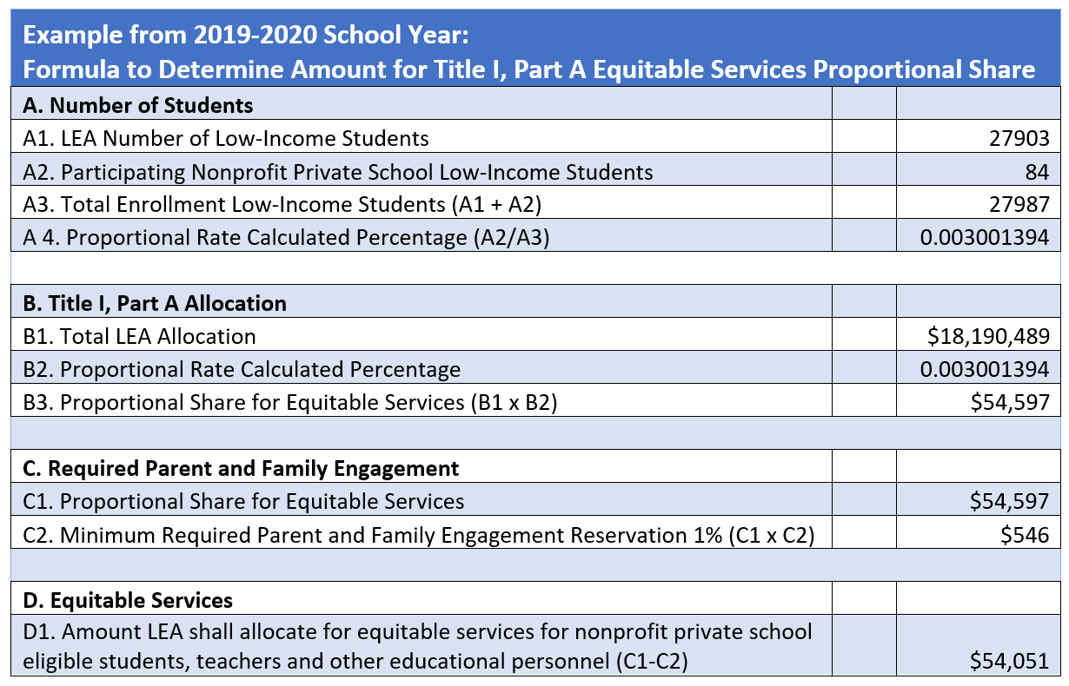

### Title II, Equitable Services Proportional Share Formula and Methodology

The Elementary and Secondary Education Act, as amended by the Every Student Succeeds Act (ESSA) Section 2102(a), requires from funds reserved by a State under ESSA Section 2101(c)(1) for a fiscal year, the State, acting through the State educational agency (SEA), shall award sub-grants to eligible local educational agencies (LEAs) from allocations described in paragraph (2). From the funds described in paragraph (1), the SEA shall allocate to each of the eligible LEAs in the State for a fiscal year the sum of:

(A) an amount that bears the same relationship to 20 percent of such funds for such fiscal year as the number of individuals aged five through seventeen in the geographic area served by the LEA, as determined by the Secretary on the basis of the most recent satisfactory data, bears to the number of those individuals in the geographic areas served by all eligible LEAs in the State, as so determined; and

(B) an amount that bears the same relationship to 80 percent of the funds for such fiscal year as the number of individuals aged five through seventeen from families with incomes below the poverty line in the geographic area served by the LEA, as determined by the Secretary on the basis of the most recent satisfactory data, bears to the number of those individuals in the geographic areas served by all the eligible LEAs in the State, as is so determined.

The amount an LEA must reserve to provide equitable services for nonprofit private school teachers and other educational personnel for Title II, Part A services is based on the LEA’s total Title II, Part A allocation, less administrative costs. The LEA determines the amount of funds available for Title II, Part A equitable services for nonprofit private school teachers and other educational personnel by calculating, on a per-pupil basis, the amount available for all public and nonprofit private school students enrolled in participating nonprofit private elementary and secondary schools in areas served by the LEA (regardless of a student’s residency), taking into consideration the number and needs of the children, their teachers and other educational personnel to be served.

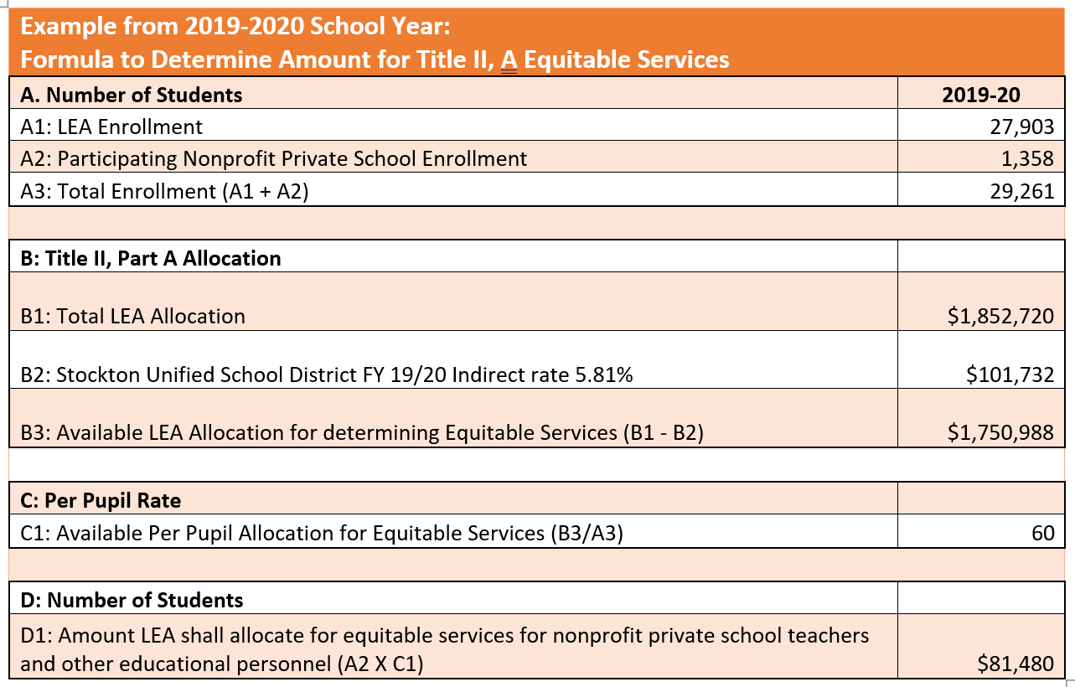

### Title IV, Equitable Services Proportional Share Formula and Methodology

The Elementary and Secondary Education Act, as amended by the Every Student Succeeds Act Section 8501(a)(4), requires that expenditures for educational services and other benefits for eligible nonprofit private school children, their teachers, and other educational personnel serving those children, under Title IV, Part A, be equal to expenditures for the public school program, taking into account the number and educational needs of the children to be served.

For 2018–19, the California Department of Education (CDE) determines the preliminary amount a local educational agency (LEA) must reserve for Title IV, Part A equitable services to children, their teachers, and other educational personnel in participating nonprofit private schools based on the relative enrollment of nonprofit private and public school students, on the assumption that these numbers also accurately reflect the relative needs of students and teachers in the public and nonprofit private schools. It is permissible for LEAs to use additional factors relating to need, and not base equal expenditures only on the relative enrollments. LEAs electing to use additional factors should do so through consultation with the nonprofit private schools participating in the grant and inform the CDE of upward revisions to amounts, if applicable.

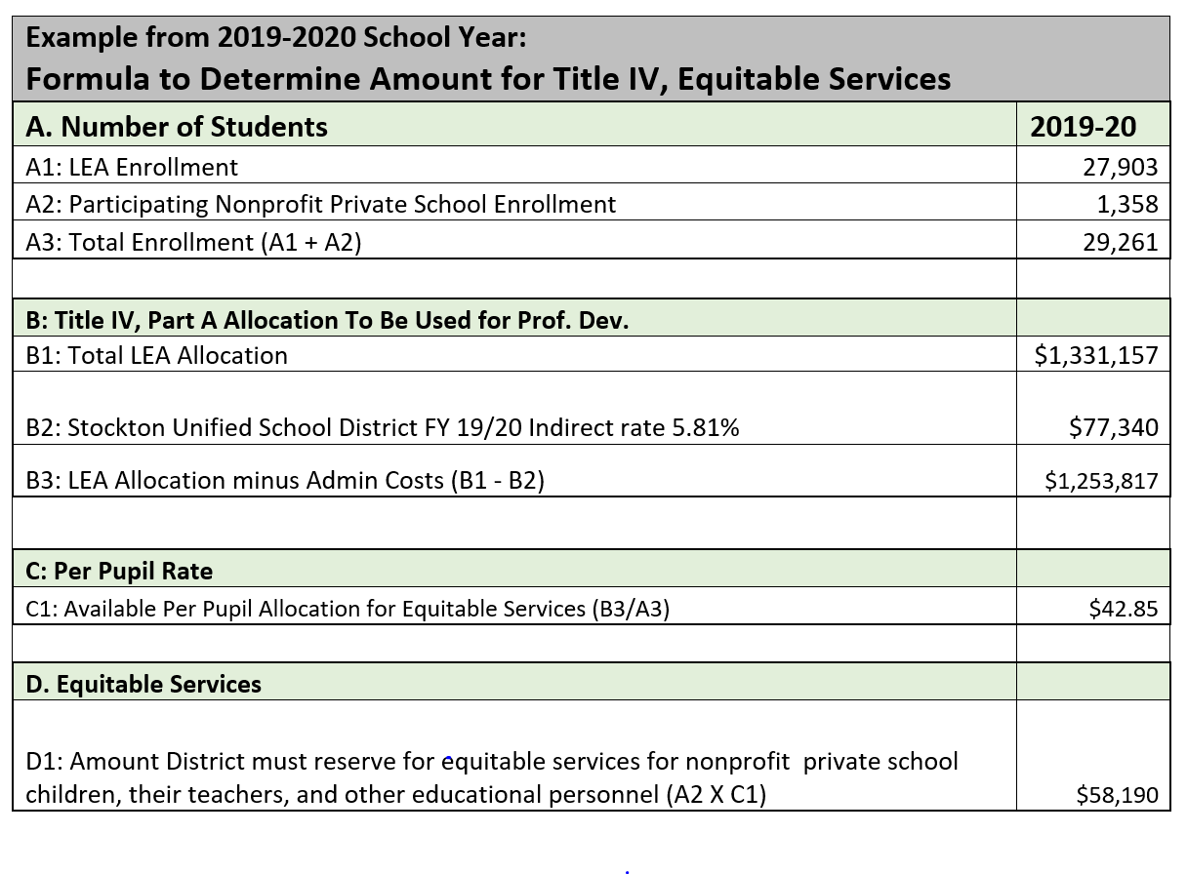

# Title I Parent Meeting

The purpose of the meeting is to inform parents of the school’s participation in Title I program, explain the requirements of Title I program, and the right of parents to be involved.

The meeting should be held early in the school year in a convenient location and at a convenient time for parents. There must be at least one (1) meeting; however, additional and on-going communication is encouraged at various meetings throughout the school year.

The meeting may be held in conjunction with Back to School Night when many parents are already on campus. Content to present:

* Title I program overview
* Parent rights under Title I
* Parent involvement at the school
* Student achievement data
* Equitable Services Plan
* Title I funding

The district has developed a PowerPoint slide deck that includes all components identified above to assist in meeting the requirements. It can be found on the district’s webpage: https://www.stocktonusd.net/Page/10029

# Home Language Survey

California *Education Code*, Sections 313 and 60810 contain legal requirements which direct schools to determine the language(s) spoken in the home of each student. This sample form is designed to assist with the identification process.

* [Home Language Survey form English(PDF; Revised Jul-2020)](https://www.cde.ca.gov/ta/cr/documents/hls2020.pdf)
* [Home Language Survey form Spanish(PDF; Revised Jul-2020)](https://www.cde.ca.gov/ta/cr/documents/hls2020spa.pdf)
* [Available Translations of the Home Language Survey form(Revised Dec-2016)](http://inet2.cde.ca.gov/cmd/translatedparentaldoc.aspx?docid=2293,%202294,%202295,%202296,%202299,%202300,%202303,%202304,%202305,%202306,%202307,%202308,%202309,%202310,%202311,%202312,%202313,%202314,%202315,%202316,%202319,%202320,%202321,%202322,%202323,%202324,%202325,%202326,%202327,%202328,%202329,%202330,%202331,%202332,%202333,%202334,%202335,%202336,%202337,%202338)

**Informal Primary Language Assessment**

Tool that may be used, along with the results of the English Language Proficiency Assessments for California (ELPAC), to design appropriate instruction and support services for English learners.

* [Informal Primary Language Assessment sample form English(DOC; Revised Dec-2010)](https://www.cde.ca.gov/ta/cr/documents/iplaenglish.doc)
* [Available Translations of the Informal Primary Language Assessment form](http://inet2.cde.ca.gov/cmd/translatedparentaldoc.aspx?docid=4126-4175)

Stockton Unified School District’s, Language Development Office, has developed the English Learner Master Plan which can provide additional support regarding the Home Language Survey. This can be location at: <https://www.stocktonusd.net/Domain/153#calendar16510/20210826/month>.

# Federal Program Monitoring

Stockton Unified School District receives Title I, II, III, and/or IV funding that is monitored by the California Department of Education’s Federal Program Monitoring office. Every two years, SUSD goes through this process involving on-site, involving in-person interviews and observations, or online. SUSD must demonstrate to the FPM office expenditure of Title I, II, III, and/or IV funds are to support to the students group and services the funds intended for.

In order to demonstrate this, SUSD reviews and responds to the FPM program instrument that articulates the evidence required to support the federal and state requirements organized into statutory core item, also considered programmatic guidance. These FPM instruments are available on the CDE’s webpage: https://www.cde.ca.gov/ta/cr/

# Equitable Services Plan Development

The purpose of the Equitable Services Plan is to provide stakeholder a view of how their eligible students, teachers, families, and staff will be supported to close the student achievement gap. The plan is intended to clearly articulate the need for specific services, what the evidenced-based services are, how they will be measured, and the outcome of the services. This plan is intended to be flexible – allowing for changes supported by documented need. The Equitable Services Plan is available at: https://www.stocktonusd.net/Page/13592

## Funding Allocation Profile

The purpose of the funding allocation profile is to have an at-a-glance overview of all Title I, II, III, and/or IV funding. The preliminary $ column is based on the initial funding allocation. The Revision $ columns will provide an overall progress of funding changes, which tie directly to the Actions/Services (formerly Strategy/Activity).

## Purpose and Description

The purpose of this section provides the nonprofit private school the opportunity to describe why there is a need for this plan, how this plan intends to meet the ESSA requirements to support students, teachers in accordance with the applicable Title I, II, III, and/or IV programs.

## Private School Demographics

The purpose of this section is to document the student data that supports the need for funding and services.

## Stakeholder Involvement

The purpose of this section is to document the meaningful and collaborative stakeholder involvement that included eligible students, teacher, and staff needs for services to meet the funding source’s intent and purpose.

## Comprehensive Needs Assessment Summary

The purpose of this section is to document how the comprehensive needs assessment process was conducted and the subsequent results that lead to the inclusion of the actions/services identified in the plan. It also provides a location for the results of assessments data to identify student gaps in learning and professional development needs. These sections provide for consideration of school accreditation findings/recommendations and demonstration of how the school goals are supported and address Title I, II, III, and/or IV funding.

## School Goals

The school goal(s) is the representation of what is intended to be achieved at the end of the project period. School goals must use S.M.A.R.T. characteristics.

## Measureable Outcomes

The purpose of this section is to document the data to be reviewed throughout the implementation of the actions/services. The baseline/actual outcome is data identified at the start of the plan development that supports the need for funding and services.

## Actions/Services

This section has two parts. The first part is to document the students to be served by the action/service. The second part is to describe in detail what the evidenced-based action/service to be implemented.

Narrative details should include a general summary of what is planned, the frequency, resources, materials, etc. for stakeholders to reasonably understand what is being implemented.

Actions/Services for materials/equipment continuously (instructional school days, intercession and holidays during the instructional calendar are exempt) in-place/in-service must be adequately described and monitored until disposed of. Therefore, if materials/equipment not in use post instructional calendar (May/June through July/August) then materials/equipment must be returned to the district (control of public funds).

Disposed of means returned to the district upon determination the material/equipment is no longer in-place, use, or in-service at any time during the school or program year.

School year and program year is defined as July 1 through June 30.

## Proposed Expenditures

The purpose of this section is to document estimated expenditures to support the action/services described in the narrative.

## Annual Review/Evaluation

The purpose of this section reports out the actual implementation, how effective was the implementation (supported by data including the measurable outcomes identified previously). The annual review/evaluation also provides an opportunity to describe any major differences between the intended implementation and the actual budgeted expenditures (activity). The last parameter is to describe any future changes that will be made to the goal, specifically relating to the measurable outcome metrics or actions/services.

## Budget Summary

The budget summary reflects the overall expenditures identified throughout the plan. It helps to provide a means for tracking and budget set up.

# Timeline for Equitable Services

The following timeline is subject to change to meet workflow and programmatic implementation.

Black = general information Blue = private school Orange = district

**July 1:** Start of the program/project year.

**July 15:** Submission of purchase requests (including consultant services), Conference Attendance Requests.

District Personnel Action (PA) submitted for applicable staff for routing through the system.

**August 1:** District responds with quotes and/or decisions for consultant services.

Draft request for proposals submitted to district Purchasing Department for approval.

Coordinate redistribution of materials/equipment for project year.

**August 15:** Purchase requisitions entered into the district system. Purchasing Department posts request for proposals.

**August 31:** Tutoring services plan and student assessment results for eligibility of services submitted.

**September 15:** Finalized tutoring services and intervention program returned to private school.

Quarterly meeting and check-in at school site, introduction of Title I teacher, and to verify location of services/materials/equipment.

**September 30:**  Title I Parent Meeting conducted, with Title I teachers attending.

**October 1:** Tutoring services begin at school sites.

**November 15:** Mid-program review of services.

**November 6:** Quarterly meeting to verify services/materials/equipment.

**January 15:** Mid-program review of services.

**January 31:**  Letters of Participation for 2021-2022 School Year.

**March 6:**  Mid-program review of services.

**March 15:** Quarterly meeting to verify services/materials/equipment.

**March 6:**  Mid-program review of services.

**April 15:** Introduction Packet and Equitable Services Plan distributed to private schools.

**May 15:**  Mid-program review of services.

**May 31:** Completion of Equitable Services Plan evaluation/annual review for SY 2020-2021.

**June 2:** Quarterly meeting and check-out at school site and coordinate pick/up of materials/equipment.

**June 30:** Equitable Services Plan final/signed submitted to district.